**Java OOPs Concepts**

Object means a real-world entity such as a pen, chair, table, computer, watch, etc. Object-Oriented Programming is a methodology or paradigm to design a program using classes and objects. It simplifies the software development and maintenance by providing some concepts:

* [Object](https://www.javatpoint.com/object-and-class-in-java)
* Class
* [Inheritance](https://www.javatpoint.com/inheritance-in-java)
* [Polymorphism](https://www.javatpoint.com/runtime-polymorphism-in-java)
* [Abstraction](https://www.javatpoint.com/abstract-class-in-java)
* [Encapsulation](https://www.javatpoint.com/encapsulation)

Smalltalk is considered the first truly object-oriented programming language.

The popular object-oriented languages are [Java](https://www.javatpoint.com/java-tutorial), [C#](https://www.javatpoint.com/c-sharp-tutorial), [PHP](https://www.javatpoint.com/php-tutorial), [Python](https://www.javatpoint.com/python-tutorial), [C++](https://www.javatpoint.com/cpp-tutorial), etc.

The main aim of object-oriented programming is to implement real-world entities for example object, classes, abstraction, inheritance, polymorphism, etc

## OOPs (Object-Oriented Programming System)

**Object** means a real-world entity such as a pen, chair, table, computer, watch, etc. **Object-Oriented Programming**

is a methodology or paradigm to design a program using classes and objects. It simplifies the software development and maintenance by providing some concepts:

* [Object](https://www.javatpoint.com/object-and-class-in-java)
* Class
* [Inheritance](https://www.javatpoint.com/inheritance-in-java)
* [Polymorphism](https://www.javatpoint.com/runtime-polymorphism-in-java)
* [Abstraction](https://www.javatpoint.com/abstract-class-in-java)
* [Encapsulation](https://www.javatpoint.com/encapsulation)

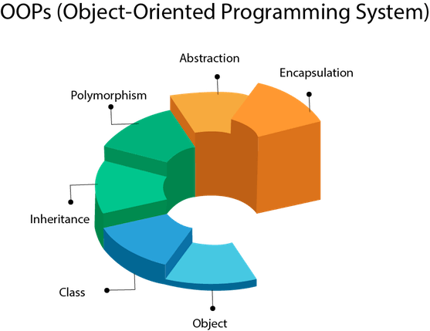

## Object

Any entity that has state and behavior is known as an object. For example a chair, pen, table, keyboard, bike, etc. It can be physical or logical.

An Object can be defined as an instance of a class.

## Class

Collection of objects is called class. It is a logical entity.

blueprint" for creating objects.

defines the attributes and behavior of the objects